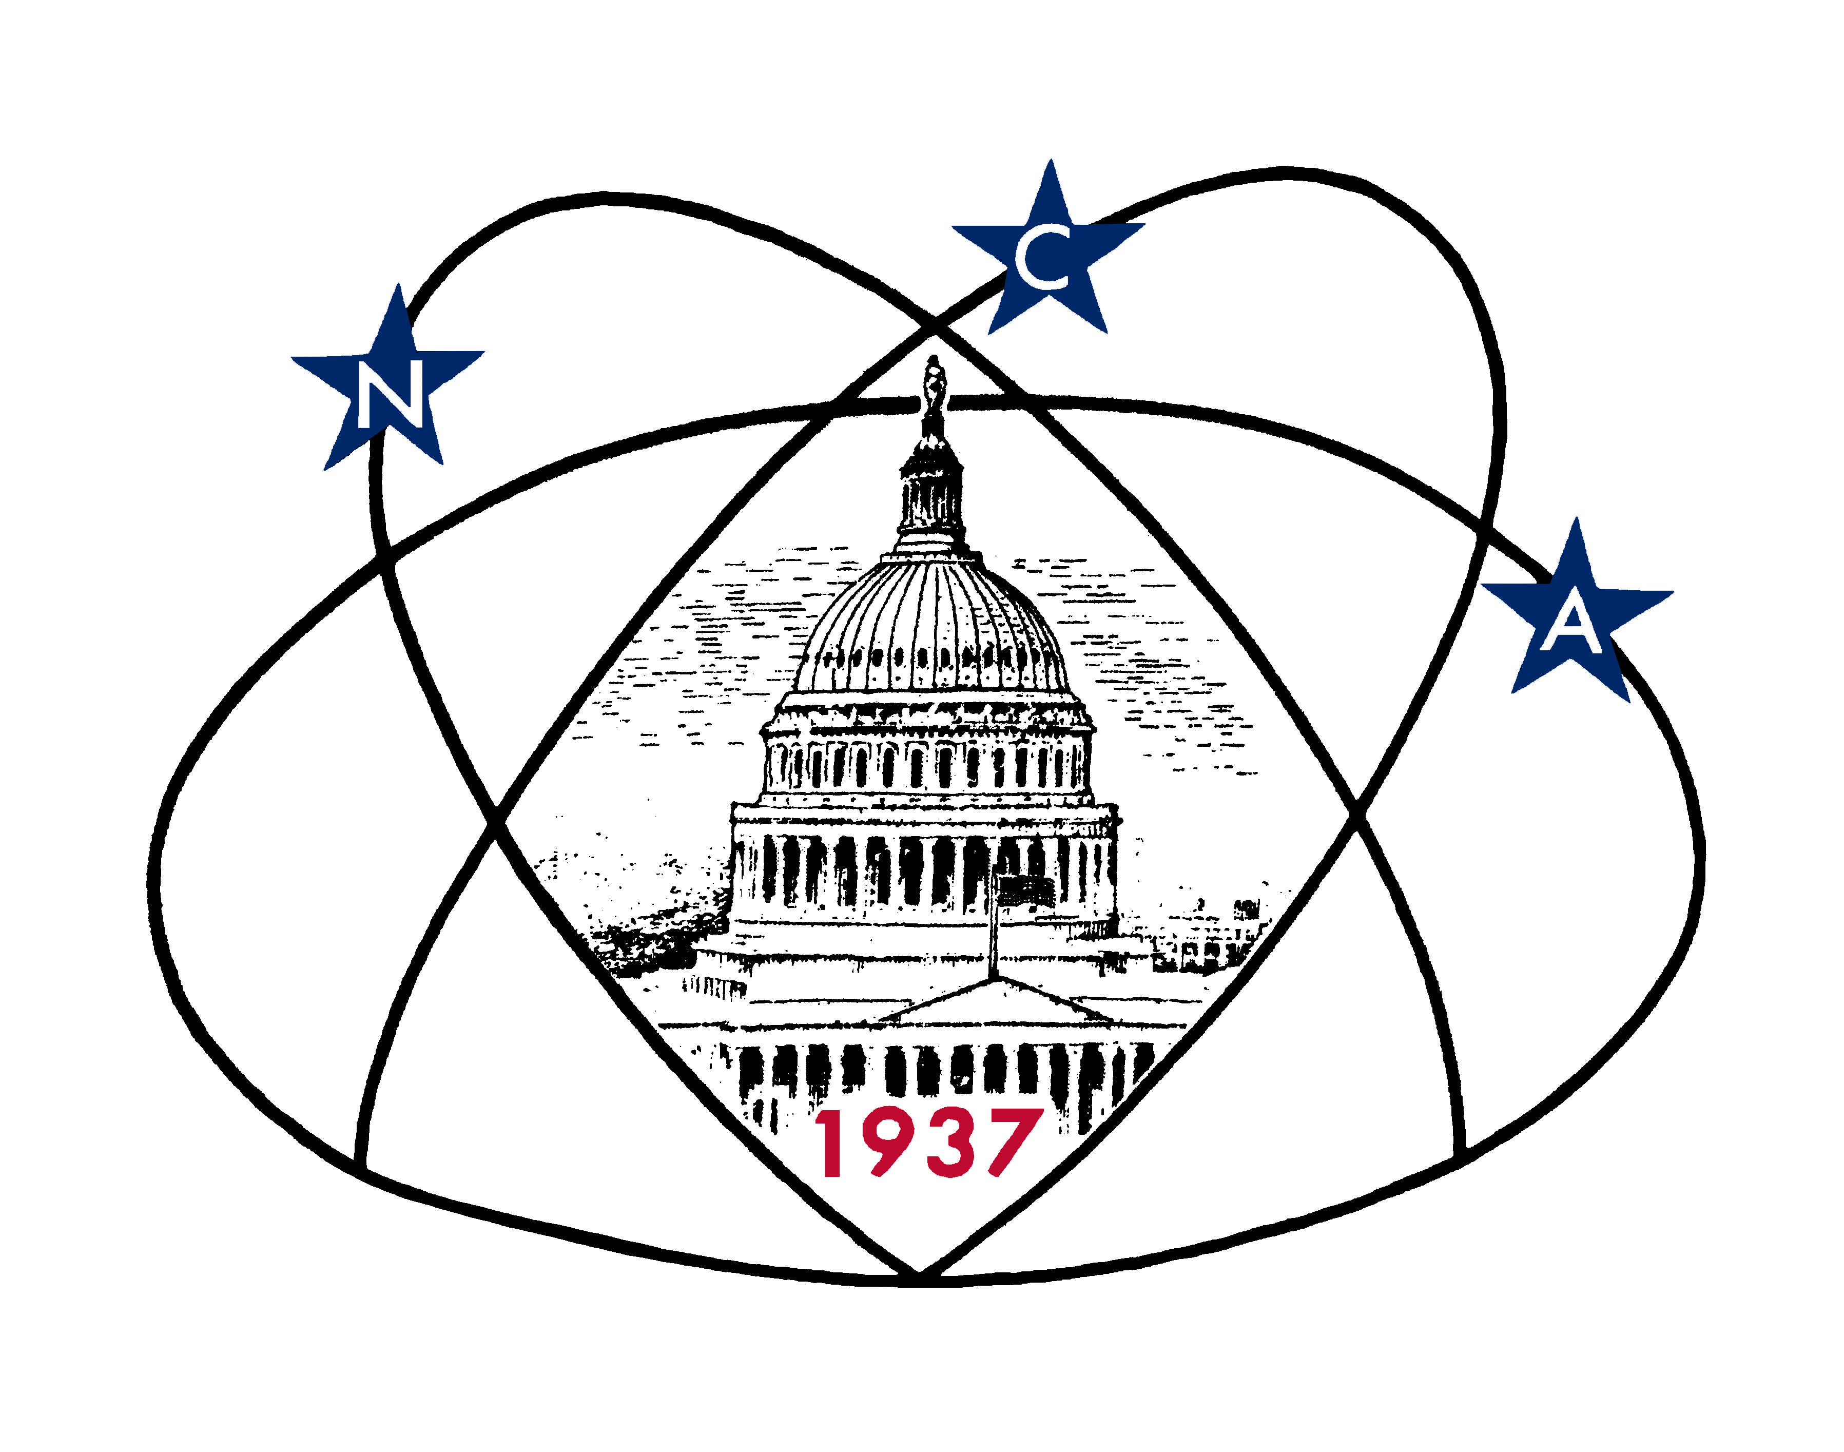

National Capital Astronomers

Authorization and Release
For Photographs, Video, and Audio Recordings

NCA EVENT:

DATE:

******************************************************************************************

I, , hereby grant to the National Capital Astronomers (NCA), its assigns or successors, for any lawful purpose at any time, the irrevocable right to make, use, and/or exhibit publicly or privately photographs of me, or writing provided by me; and/or to produce video or audio recordings of me. This grant of rights to NCA includes, but is not limited to, print, electronic, digital, other materials, or any other media produced for educational, promotional, commercial, or informational purposes; and any other format for the storage, retrieval, and reproduction of information, images, and sounds.

I hereby agree to release, defend, and hold harmless NCA, its agents or employees, including any firm publishing and/or distributing the finished product in whole or in part, whether on paper, via electronic media, or any other media, from and against any claims, damages, or liability arising from or related to the use of my name, likeness, or materials including but not limited to any misuse, distortion, blurring, alteration, optical illusion or use in composite form, either intentionally or otherwise, that may occur or be produced in taking, processing, reproduction or production of the finished product, its publication or distribution.

I hereby waive any right to inspect or approve the finished product, or the use to which it may be applied now or in the future, whether the use is known to me or unknown. I waive any right to royalties or other compensation arising from or related to the use of materials I provide to NCA or my name and likeness.

I have read this agreement before signing below and warrant that I fully understand its contents.

Name Date

School/Company

Address

Parent or Guardian Date
(if under 18 years of age)

